Exercise 4.1 (refractive index of glasses)
- How can the refractive index in silica based glasses be tuned? Provide a couple of examples.
- Where are low and high refractive index glasses used, where are combinations of high and low refractive index glasses used?
- Consider an achromate shown as below with the focal length f = 200 mm with a crown glass (n₁ =1.5 and Abbe number v₁ = 70) for the positive lens in front and a flint glass (n₂ = 1.6) for the negative lens. The cemented surface should be plane and the focal length of the crown lens is given as f₁ = 70 mm.
- Calculate the focal length of the flint lens and the radii of curvature of the outer surfaces.
- Calculate the necessary Abbe number of the flint lens to fulfill achromatization condition. Is this a realistic value?

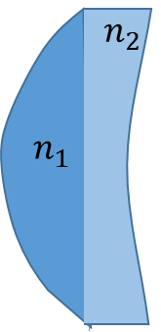
Exercise 4.2 (optical fibers)
- Calculate the numerical aperture NA of a fiber, which is defined by ${NA=sin⁡(θ}_{i})$, where $θ_{i}$ is the maximum angle of incidence where light of a particular wavelength can be transmitted through the fiber. Use the refractive index $n_{0}$ for air, the refractive index $n_{1}=1.5$ for the core of the fibre and $n_{2}=1.3$ for the cladding.
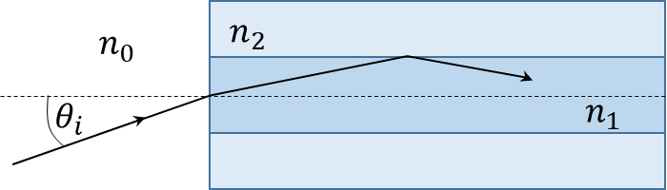

- The optical loss of an optical fiber has to be lower than 20 dB/km in order to compete with coaxial cables. Determine this attenuation as a ratio and the received power after 1 km if the launch power is 3 mW.
- What are optical losses in fibers due to?

